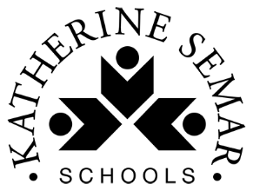
Home Learning Tasks for Year 2

This home learning letter provides your child with learning activities from various areas of the curriculum to complete at home. Each area of learning will have a link which you can use to access the work. Please ensure the maths and English tasks are completed in the morning and the foundation activities (science and topic) in the afternoon, as it would be in school.

One maths, English and phonics task should be completed every day. One foundation activity must be completed each day, your child can choose between science and topic. Please ensure your child reads every day.
English  (x 60 minutes each day) | Humorous poetry KS1 | Y2 English | Lesson Resources | Oak National Academy  Follow the link above to Oak Academy to the unit of work on Humorous Poetry to access daily writing activities.
Spelling  (x 15 minutes per day) | Follow the link to Phonics Play https://www.phonicsplay.co.uk/ and select a free phase 5 activity to play.  Log in to spelling play https://www.spellingplay.co.uk/y2_member/planning_year2_spelling.html and play the suffix games.  Practise the common exception words that we are learning this year.  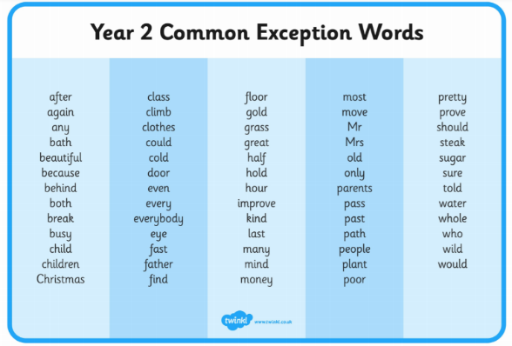
Maths  (x 60 minutes) | 10MM  Practise the 2,5 and 10 times tables every day using any method that you like. The aim is to recall them quickly and in any order.  You might like to use:  Hit the Button https://www.topmarks.co.uk/maths-games/hit-the-button  TTRockstars https://ttrockstars.com/
Maths  (x 60 minutes) | In mathematics, we would like you to complete daily lessons using Oak Academy.  Free KS1 Maths Lesson & Curriculum Resources | Oak National Academy
Science/Design Technology  (x 40 minutes) | We are learning about plants. Please complete these lessons.  Unit: Growing plants | KS1 Science | Oak National Academy (thenational.academy)
Topic  (x 40 minutes) | In history we are looking at Neil Armstrong and his significance to history. Now spend some time learning about other significant individuals in history and create a poster about their achievements using the link below.  Significant individuals: how did they change the world? KS1 | Y2 History | Lesson Resources | Oak National Academy
Reading  For Pleasure  (x 20mins per day) | Read a book of your choice, discussing it with an adult.  Login to your Bugclub account, read your allocated books and do the comprehension activities.
Physical Exercise  (x 30 minutes) | Try some of ‘The Body Coach’ workouts:  https://www.youtube.com/playlist?list=PLyCLoPd4VxBvPHOpzoEk5onAEbq40g2-k  Stretch, bend and get movin’ with the Cosmic Kids Yoga YouTube channel, where you’ll find 10-20 minute guided yoga workouts:  https://www.youtube.com/user/CosmicKidsYoga
Independent Play | Play allows children to use their creativity while developing their imagination, dexterity, and physical, cognitive, and emotional strength. Play is important to healthy brain development.  It is through play that children at a very early age engage and interact in the world around them.  So remember to get your toys out and play for at least an hour a day!

