
Home Learning Tasks for Year 1

This home learning letter provides your child with learning activities from various areas of the curriculum to complete at home. Each area of learning will have a link which you can use to access the work. Please ensure the maths and English tasks are completed in the morning and the foundation activities (science and topic) in the afternoon, as it would be in school.

One maths, English and phonics task should be completed every day. One foundation activity must be completed each day, your child can choose between science and topic. Please ensure your child reads every day.
English  (x 60 minutes each day) | Complete a unit of work on Jack and the beanstalk .  Unit: 'Jack and the Beanstalk': reading and writing | KS1 English | Oak National Academy (thenational.academy)
Phonics  (x 15 minutes per day) | Follow the link to Phonics Play (https://www.phonicsplay.co.uk/) and play a free phase 5 activity.  Practise reading and spelling the year 1 common exception words.  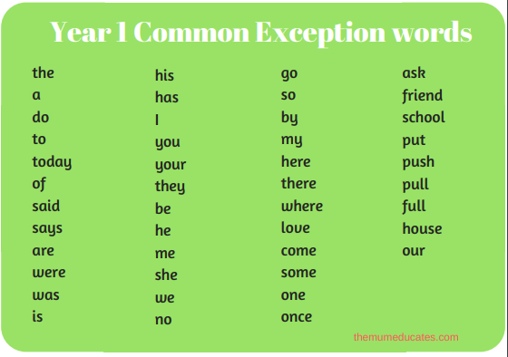  You could do this by:  - writing them in rainbow colours  - writing them in bubble writing  - building each letter out of playdoh to make the word  - hiding them around the house and when you find one, read it then write it 5 times  - seeing how many you can write in a minute  - writing them into a sentence
Maths  (x 60 minutes) | 10MM  Practice writing your number bonds to 10 (and different numbers up to 10) every day.  You could do this on Hit the Button: https://www.topmarks.co.uk/maths-games/hit-the-button.
Maths  (x 60 minutes) | In mathematics we would like you to complete daily lessons using Oak Academy. Use the link below to access these lessons. Each unit (sequence of lessons with a given topic) is numbered and click on ‘see unit’, access each lesson by clicking ‘view lesson in classroom.’ Complete one lesson per day – each lesson provided has a teaching video and a main activity.  Complete the unit on counting in 2’s, 5’s and 10s.  Unitising and coin recognition - counting in 2s, 5s and 10s KS1 | Y1 Maths | Lesson Resources | Oak National Academy
Science  (x 40 minutes) | This half-term we are learning all about forces. Watch the below videos and see if you can explain to a grown-up how a car might move if you push it along.  What are the different forces? - BBC Bitesize  You could set up an experiment to explore what might affect how far a push-car can travel. You could set ramps at different heights and find the best height for both speed and distance. Take photos to put on see-saw and use the key words 'push', 'unbalanced' and 'forces' to explain what happens.
Topic  (x 40 minutes) | Art  In Art, we are learning all about painting and how the mix colours to acheive a desired effect. We will be learning all about Wassily Kandinsky - you could try to recreate his famous Concentric circles.  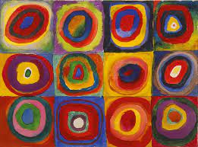  You could also explore the Oak Academy for further learning about painting: Art and design, primary, Year 1 - Unit listing | Oak National Academy  History  In History, we will be exploring the topic of significant individuals. Please look at the ‘Explorers and Adventurers’ topic on The Oak Academy and follow the lessons in unit 4 Significant explorers: How has seafaring changed over time?  You can find the link to the lessons here:  History, primary, Year 1 - Unit listing | Oak National Academy
Reading  For Pleasure  (x 20mins per day) | Read a book of your choice, discussing it with an adult.  Login to your Bugclub account, read your allocated books and try the comprehension activities. Please email the school office if you need extra books added.
Physical Exercise  (x 30 minutes) | Try some of ‘The Body Coach’ workouts:  https://www.youtube.com/playlist?list=PLyCLoPd4VxBvPHOpzoEk5onAEbq40g2-k  Stretch, bend and get movin’ with the Cosmic Kids Yoga YouTube channel, where you’ll find 10-20 minute guided yoga workouts:  https://www.youtube.com/user/CosmicKidsYoga
Independent Play | Play allows children to use their creativity while developing their imagination, dexterity, and physical, cognitive, and emotional strength. Play is important to healthy brain development.  It is through play that children at a very early age engage and interact in the world around them.  So remember to get your toys out and play for at least an hour a day!

