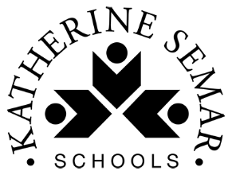
Home Learning Tasks for Year 2

This home learning letter provides your child with learning activities from various areas of the curriculum to complete at home. Each area of learning will have a link which you can use to access the work. Please ensure the maths and English tasks are completed in the morning and the foundation activities (science and topic) in the afternoon, as it would be in school.
One maths, English and phonics task should be completed every day. One foundation activity must be completed each day, your child can choose between science and topic. Please ensure your child reads every day.
Bug Club – To access your child’s Bug Club login, please see the front of their reading diary where you will find their username and their password. You will also need to use the school code too which is (ksis).
If you do not have your child’s login details please contact the school office and we can give it out to you.
English  (x 60 minutes each day) | This half term we are learning about ‘Warning Stories’ with a focus on our key text: The Minpins by Roald Dahl.  Read the story https://www.youtube.com/watch?v=rjDBsBuHhu8 0minutes-19minutes  - Write a character description for Billy.  - Draw a picture of what you think a spittler looks like? Add labels to your drawings.  - Write some sentences about a spittler using clues from the story. Make sure you use capital letters and full stops. Use conjunctions where necessary.  - How do you think Billy felt as he was venturing into the forest? Why do you think he would say? What questions would you ask him? What would you advise him to do?  - Have a go at writing your own ‘Warning story’ beginning. Who will your characters be? Where are they? What have they been warned not to do?
Spelling  (x 15 minutes per day) | Follow the link to Phonics Play https://www.phonicsplay.co.uk/ and select a free phase 5 activity to play.  Follow the link to spelling play https://www.spellingplay.co.uk/planning-and-resources/year-2/vowel-suffixes/violets-vowel-suffixes and play the suffix games.  There are more interactive spelling games here https://www.spellingplay.co.uk/interactive-resources which you may enjoy also.  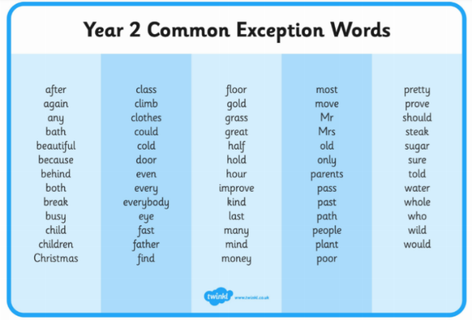  Practice reading and spelling the common exception words that we have learnt in the autumn term.
Maths  (x 60 minutes) | 10 MM  Practise your number bonds to 10, 20 and 100 (multiples of 10 adding to 100) every day.
Maths  (x 60 minutes) | In mathematics we would like you to complete daily lessons using Oak Academy. Use the link below to access these lessons. Each unit (sequence of lessons with a given topic) is numbered and click on ‘see unit’, access each lesson by clicking ‘view lesson in classroom.’ Complete one lesson per day – each lesson provided has a teaching video and a main activity.  Please complete unit 8 (Representing counting in 2s, 5s and 10s as the 2, 5 and 10 times tables).  Free Primary Maths Lesson & Curriculum Resources | Oak National Academy
Science  (x 40 minutes) | Follow the daily science lessons from Oak Academy. The learning topic is Uses of Everyday Materials.  Science, primary, Year 2 - Lesson listing | Oak National Academy  Have a look around your house and record what the items are made from. Why are they made out of that material?  Create your own materials fact file displaying the knowledge you have learnt.
RE | Follow the lessons from Oak Academy. The learning topic is The Bible: what does it say about God's promises?  Religious education, primary, Year 2 - Lesson listing | Oak National Academy
Topic  (x 40 minutes) | Follow the lesson from Oak Academy. The learning topic is The Great Fire of London.  Generating knowledge about The Great Fire of London | Oak National Academy
Reading  For Pleasure  (x 20mins per day) | Read a book of your choice, discussing it with an adult.  Login to your Bugclub account, read your allocated books and try the comprehension activities.
Physical Exercise  (x 30 minutes) | Try some of ‘The Body Coach’ workouts:  https://www.youtube.com/playlist?list=PLyCLoPd4VxBvPHOpzoEk5onAEbq40g2-k  Stretch, bend and get movin’ with the Cosmic Kids Yoga YouTube channel, where you’ll find 10-20 minute guided yoga workouts:  https://www.youtube.com/user/CosmicKidsYoga
Independent Play | Play allows children to use their creativity while developing their imagination, dexterity, and physical, cognitive, and emotional strength. Play is important to healthy brain development.  It is through play that children at a very early age engage and interact in the world around them.  So remember to get your toys out and play for at least an hour a day!

