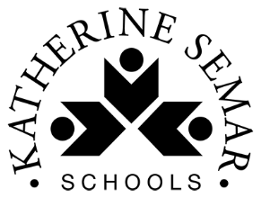
Home Learning Tasks for Year 1

This home learning letter provides your child with learning activities from various areas of the curriculum to complete at home. Each area of learning will have a link which you can use to access the work. Please ensure the maths and English tasks are completed in the morning and the foundation activities (science and topic) in the afternoon, as it would be in school.
One maths, English and phonics task should be completed every day. One foundation activity must be completed each day, your child can choose between science and topic. Please ensure your child reads every day.
Bug Club – To access your child’s Bug Club login, please see the front of their reading diary where you will find their username and their password. You will also need to use the school code too which is (ksis).
If you do not have your child’s login details please contact the school office and we can give it out to you.
English  (x 60 minutes each day) | Over the next half-term, we will be learning about Defeating the Monster stories. Our key text in school is The Three Little Pigs. We will also be looking at ‘Huff Puff Houses’ for our poetry.  Below are some suggested stories or clips to watch and some linked activities to work through. There are ten activities so you can complete one each day.  ‘On The Way Home’ by Jill Murphy.  https://www.youtube.com/watch?v=URRAMHToe4s  - Before reading the story, can you write what you think may happen to the girl on the way home?  - Can you write one way that Claire could have hurt her knee? Which monster did she defeat and how did they trip her over?  - Can you make a list of all of the characters that Claire meets on her journey home? Can you describe each of them with an adjective? E.g. a green slithery snake.  - There are lots of different characters in the book such as the Woodcutter. Can you think of any other stories of films that they have appeared in?  - Choose a monster. Can you write a description of them using adjectives, capital letters and full stops?  - Choose a monster. Can you write a story about them and what they might do next?  Topic related writing  - Can you write about your favourite fairy-tale and explain why? Make sure you use capital letters and full stops appropriately.  - Who is your favourite character from a story book? Can you describe them using the word ‘and’ to join your sentences?  Hansel and Gretel  https://www.youtube.com/watch?v=wDQib9yeEn0  - Can you design a house made of sweets? Can you label the parts of the house?  - What was your favourite part of the story and why?  - Can you make a story map for the story and retell it to and adult?
Phonics  (x 15 minutes per day) | Learn the phonemes:  ou Lesson 32 - Year 1 (youtube.com)  oy Lesson 33 - Year 1 (youtube.com)  ar/ a Lesson 39 - ar/a mask (youtube.com)  Revisit:  ai/ ay alternative graphemes Lesson 53 - Year 1 - YouTube  igh/ ie alternative graphemes Lesson 52 - Year 1 (youtube.com)  oa/ oe alternative graphemes Lesson 54 - Year 1 (youtube.com)  Follow the link to Phonics Play https://www.phonicsplay.co.uk/ and select a free phase 5 activity to play.  Practice reading and spelling your tricky words – we have now learnt to read them all!  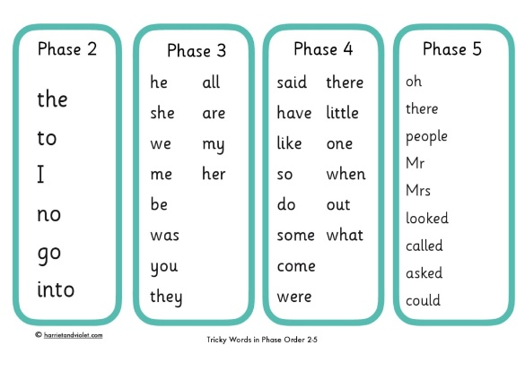
Maths  (x 60 minutes) | 10 MM  Practice writing your number bonds to 10 every day.
Maths  (x 60 minutes) | In mathematics we would like you to complete daily lessons using Oak Academy. Use the link below to access these lessons. Each unit (sequence of lessons with a given topic) is numbered, click on ‘see unit’, access each lesson by clicking ‘view lesson in classroom.’ Complete one lesson per day – each lesson provided has a teaching video and a main activity.  Complete unit 10 (addition and subtraction). If you finish, complete unit 7 (shape).  Free Primary Maths Lesson & Curriculum Resources | Oak National Academy
Science  (x 40 minutes) | Follow the daily science lessons from Oak Academy. We will be exploring Materials and describing their properties. We will also be testing them to find out which are suitable for different purposes and exploring where materials come from.  The overarching topic is Materials. You can follow the Oak Academy unit on Materials here:  Science, primary, Year 1 - Lesson listing | Oak National Academy
Topic  (x 40 minutes) | Follow the DT lessons from the Oak Academy. The learning topic in DT links to building things.  Design and technology, primary, Year 1 - Lesson listing | Oak National Academy
Reading  For Pleasure  (x 20mins per day) | Read a book of your choice, discussing it with an adult.  Login to your Bugclub account, read your allocated books and try the comprehension activities. Please email the school office if you need extra books added.
Physical Exercise  (x 30 minutes) | Create a free imoves account and access a variety of physical activities from home:  https://imoves.com/  Try some of ‘The Body Coach’ workouts:  https://www.youtube.com/playlist?list=PLyCLoPd4VxBvPHOpzoEk5onAEbq40g2-k  Stretch, bend and get movin’ with the Cosmic Kids Yoga YouTube channel, where you’ll find 10-20 minute guided yoga workouts:  https://www.youtube.com/user/CosmicKidsYoga
Independent Play | Play allows children to use their creativity while developing their imagination, dexterity, and physical, cognitive, and emotional strength. Play is important to healthy brain development.  It is through play that children at a very early age engage and interact in the world around them.  So remember to get your toys out and play for at least an hour a day!

