Home Learning Tasks for Y1



This home learning letter provides your child with learning activities from various areas of the curriculum to complete at home. Each area of learning will have a link which you can use to access the work. It has been created so the Maths, Phonics and English tasks can be completed in the morning and the foundation activities (topic) in the afternoon, as it would be in school.
One maths, English and phonics task should be completed every day. One foundation activity must be completed each day, your child can choose between science and topic. Please ensure your child reads every day.
Bug Club – To access your child’s Bug Club login, please see the front of their reading diary where you will find their username and their password. You will also need to use the school code too which is (ksis).
If you do not have your child’s login details please contact the school office and we can give it out to you.
English  (x 60 minutes each day) | This half term our topic is ‘Superheroes’, we have been looking at instructions for how to be a superhero.  Please see below for the oral text ‘How to be a superhero’.  We have discussed what the key parts of instructions are and where we might see them in our everyday lives. You might like to complete some of the following activities at home:  - Can you give instructions for someone in your household so that they can move from one place to another?  - Can you retell the oral text ‘How to be a superhero’ to someone else? Make actions for each step to help you remember.  - The words in yellow (flowing, mission and defeat) are new vocabulary. Can you draw a picture to show your understanding of each of them?  - If you were a superhero what missions would you go on? Can you them down in a sentence using the following sentence starter (My mission would be ……).  - Sort the words in the table into imperative verbs (bossy words that tell you what to do) and nouns (objects or things.) Can you put each imperative verb into an instruction giving sentence? E.g ‘Run up and down the garden 5 times.’  - Can you correct these sentences by adding finger spaces, full stops and capital letters? You could write them out in full sentences to also practise your handwriting.
  sit | dog | sheep | jump
  skip | chair | hop | tent
  box | run | put | sleep
  batman has a black mask and bigboots
  we need to help batman
  donot rob that bank
  the badcat needs to be stopped
  it is not fair to steal themoney
Handwriting  (x10 minutes per day) | We have been practising the letters: l, i, t, u, y this week. You could consolidate this learning by practising two of these each day.  Make sure they sit on the line. The y should go under the line.  If you are already confident with this, you could apply it to writing these words:  ill  lit  till
Phonics  (x 15 minutes per day) | In phonics, we will be focusing on further consolidation of phase 3 and 4. Choose one from each part to do each day.  Revisit:  - Revisit your sounds by shouting them out as they flout past on the ship: https://www.phonicsbloom.com/uk/game/flash-cards?phase=3  - Join in with Mrs Gilkes as she revisits the previously taught graphemes: https://youtu.be/HPWUPfX32jQ  - Join in with Mrs Gilkes as she revisits the previously taught tricky words:  Phase 3: https://youtu.be/n8inzXg1se0  Phase 4: https://youtu.be/YMcHfzu_BRo  Practise:  - Play picnic on pluto to practise your blending: https://www.phonicsplay.co.uk/resources/phase/4/picnic-on-pluto  - Choose a selection of tricky words to write on post-its and hide around the house. Time your child to see how quickly they can find and read them.  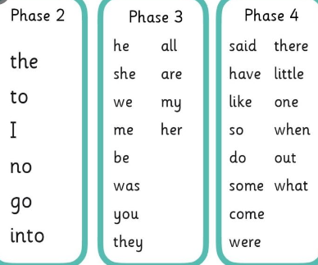  - Using the pictures labelled phonics practise 1 below, cover a picture and ask your child to write what has been covered. E.g if the rainbow is covered, they can write rainbow. As a challenge, they could put it into a sentence.  - Choose 2 tricky words and play noughts and crosses with them  - Play the roll and read phonics game below.  Apply:  - Phonics Play Comics – this site is completely free and is part of the Phonics Play website. Please take a look at the link below where the children can access a comic. There are many other comics on their website so please take a look! https://phonicsplaycomics.co.uk/comic_ph4_lunch_box.htmlThe comics are a wonderful link to our topic as well as linking to our phonics too.  Ask your children to write one of the below:  - The starlight at nights is bright. The moon is not as bright.  - Can you get to the top of the tree? It looks high up.  - The toad had a black coat and pink boots. He did not look too smart.  - She went to the shops on the weekend. He went to the farmyard.  For extra challenge, as the children to add the word and, so, but or because to extend the sentence with their own ideas.  For support choose a few words from each sentence for your child to write. You could segment the sounds together.
Maths  (x 60 minutes) | 10MM – please choose one of these a day which can be completed independently.  - Practise writing your numbers from 0 to 10, ensuring that they start and finish in the correct place.  - Play the Blast Off game, counting forwards and backwards up to 10. Blast Off when you reach 0 or 10. To challenge yourself start from any number.  - Numberblocks on BBC IPlayer has some great videos that think with our maths work from this half term. There are also some catchy number songs too for the children to enjoy.
Maths  (x 60 minutes) | https://www.thenational.academy/teachers/programmes/maths-primary-ks1/units/counting-to-and-from-20/lessons  Please use the above link to Oak Academy for the daily maths activity. The activities focus on counting forwards and backwards as well as looking at one more and one less. Each daily lesson provides a learning video to follow with an activity to complete. Start at lesson 1 and continue to work your way through the lessons each day.  If your child can complete these with ease, and can explain why each time, try the challenges each day! These are at the bottom of this letter.
Science  (x 40 minutes) | In Science this half term we are looking at Seasonal Change. We are looking at how the weather changes and what happens to the trees as we enter the Autumn.  - Take a look at this video all about the seasons. Can you draw a picture for each season to help you remember what it is like in each one? https://www.bbc.co.uk/bitesize/topics/zkvv4wx/articles/zcx3gk7  - What do you notice about the trees outside? What is happening to them? Write a sentence about what you can see.  - What are the names of the 4 seasons? Which season have we just finished and what season has just started?  - What colours might you see during this season? Draw/paint a picture or create a collage to reflect the different colours of Autumn.
Geography  (x 40 minutes) | In Geography we are looking at the Continents and Oceans from around the world. Watch the videos below for catchy songs and try to learn them both:  https://www.youtube.com/watch?v=K6DSMZ8b3LE (Continent Song)  https://www.youtube.com/watch?v=X6BE4VcYngQ&t=16s (Oceans Song)  Activity options:  - Take a look at the lesson on ‘What is a continent?’ – this video looks at where the different continents are on the world map Mapping the world: locating the continents | Oak National Academy Look at a picture of a world map. Can you find the different continents? Do you remember any of their names?  - What is your favourite fruit or vegetable? Can you find out which country it grows in and which continent that country is in? Try looking at the packet to help you! You could write some sentences to about this to show your friends when you return to school.  - Create a poster about the country where your favourite piece of fruit or vegetables grow.  - Learn the words to the song ‘Cauliflowers fluffy’. This song helps us to remember a selection of fruit and vegetables grown in England – https://www.youtube.com/watch?v=PukdaXUzgOU
Reading  For Pleasure  (x 20mins per day) | Read a book of your choice, discussing it with an adult.  Login to your Bug Club account, read your allocated books and try the comprehension activities. You can build up coins by answering the questions with a bug.  You can access Bug Club online using the following link:  https://www.activelearnprimary.co.uk/login?c=0
Physical Exercise  (x 30 minutes) | Use this link for physical activities with Joe Wickes to complete at home. There are links to lots of his other workouts too that can be located from here. https://www.youtube.com/watch?v=zKhGfdSvG3s  You might even want to create your own game!
Independent Play | Play allows children to use their creativity while developing their imagination, dexterity, and physical, cognitive, and emotional strength. Play is important to healthy brain development.  It is through play that children at a very early age engage and interact in the world around them.  So remember to get your toys out and play for at least an hour a day!
Oral text for English
Instructions – How to be a Superhero

What will you need
A cape
A mask
Special Powers

- First put on a flowing cape and a mask.
- Next, wait for a mission.
- Then rescue anyone in danger using your special powers.
- After that defeat the enemy.
- Finally get some rest so you are ready for the next mission.
Phonics practise game 1
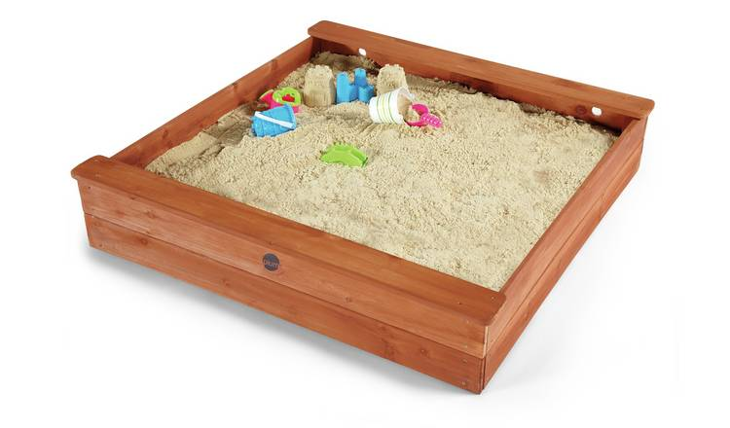 | 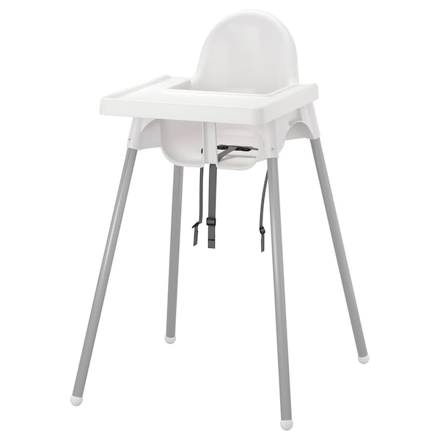 | 
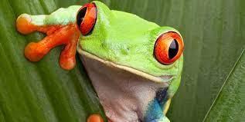 |  | 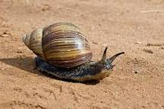

Phonics practise game 2
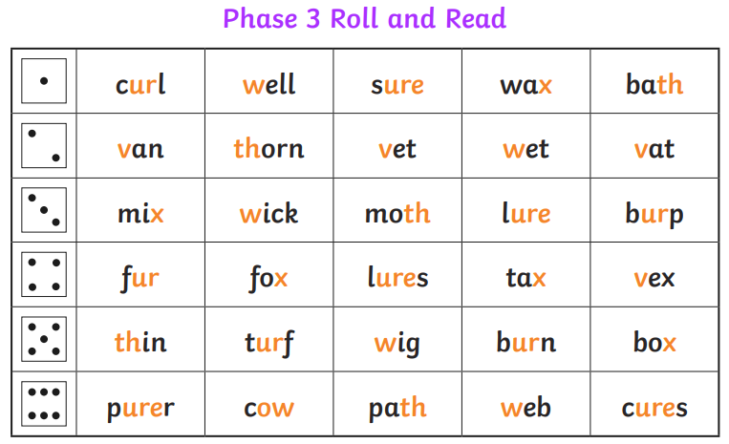

Maths challenges
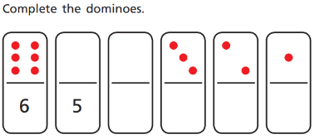
- Counting backwards:

- One more
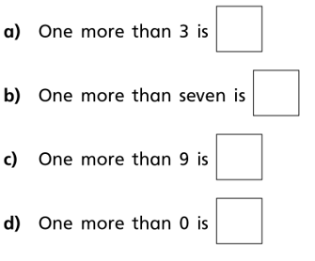

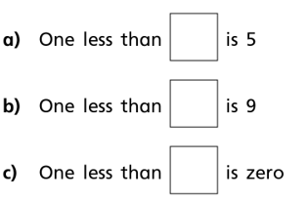
- One less

- One more and one less


